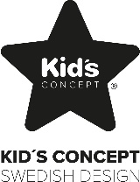
EC-Declaration of Conformity

- Product Number: 1001054

- Name and Address of the manufacturer:
Sweden Concepts AB, Prognosgatan 8A, 504 64 Borås, SWEDEN

- This Declaration is issued under the sole responsibility of the manufacturer.
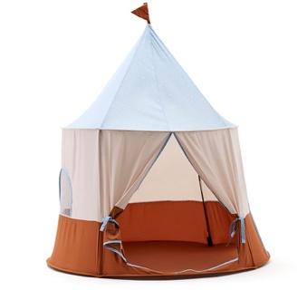
- Object of declaration:
Play tent circus blue

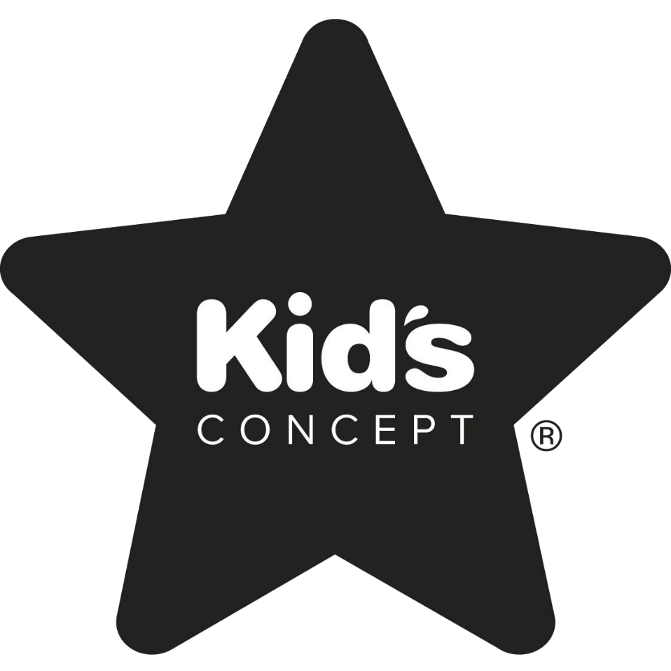
- The object of the declaration described in point 4 is in conformity with the relevant Community harmonization legislation listed below:
Directive No 2009/48/EC – Safety of Toys and its amendments

- Harmonized Standard Used:
- EN 71-1:2014+A1:2018 – Safety of toys – Part 1: Mechanical and physical properties
- EN 71-2:2020 – Safety of toys – Part 2: Flammability
- EN 71-3:2019+A1:2021 – Safety of toys – Part 3: Migration of certain elements
- EN71-9:2005+A1:2007 – Safety of toys – Part 9: Content of Formaldehyde
- BS EN71-1:2014+A1:2018 Mechanical and Physical Properties
- BS EN71-2:2020 Flammability
- BS EN71-3:2019+A1:2021 Migration of certain elements

- EC Type Examination:
Not applicable.

- Additional Information:
Not applicable.
For and on behalf of the Manufacturer
Borås 2025-09-03
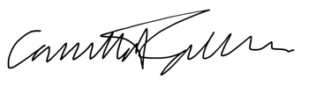
Camilla Fahlander - Buyer

